FAMILY DRUG AND ALCOHOL COURT

FDAC
National Unit,
July

2018

–

FDAC
P
ost
-
proceedings

Handbook

FDAC
POST
-
PROCEEDINGS
HANDBOOK

This document must not be reproduced without the permission of the Centre for Justice Innovation.

FAMILY DRUG AND ALCOHOL COURT
POST-PROCEEDINGS HANDBOOK

Content

INTRODUCTION 4
BACKGROUND AND AIMS 5
POST-PROCEEDINGS SUPPORT 9
REFERENCES 12

Introduction

The Family Drug and Alcohol Court (FDAC) is an evidence-based intervention, which combines a ‘problem solving’ family court and a ‘trauma-informed’ whole-family assessment and treatment team. FDAC works with families in care proceedings where it is likely that parental substance misuse has contributed to proceedings being issued. FDAC aims to provide a better experience of justice for parents and professionals, better outcomes for children and families and better use of public money.

Figure 1. The who, what, how and why of FDAC
Population  Who?  Families in care proceedings where children are put at risk by parental substance misuse | Evidence-base Intervention  What & how?  Specially trained judge and whole family assessment and treatment team  Principals of ‘problem-solving justice’ and ‘trauma-informed care’ | Outcomes  Why?  Specially trained judge and whole family assessment and treatment team  Principals of ‘problem-solving justice’ and ‘trauma informed care’

The Life Chances Fund FDAC was a project that the now defunct FDAC NU worked on in 2017-18. In the end the FDAC NU withdrew their application because of lack of support from local authorities, but not before the Director, Dr Mike Shaw, had designed a 2 year post-proceedings intervention.

This handbook has been prepared for local authorities, their FDAC teams, and the court service as a guide to post-proceedings support. You are welcome to use it as a basis for developing your own service.

The background and aims

Background

The problems that bring families into care proceedings (intimate partner abuse, substance misuse, mental illness, learning difficulties, debt, housing problems, or criminal activity) tend to run a chronic and relapsing course.

Post-proceedings relapse, further abuse or neglect, and placement breakdowns are common:
- Wade ¹ found that 35% of returns breakdown within six months.
- While Farmer ² found:
  - That almost half (47 per cent) breakdown within two years.
  - That as many as a third of the placements that did not breakdown, were of poor quality for the children. o That 78% of substance misusing parents abused or neglected their children following return.

Pressure is growing within the family justice system for feedback about post-proceedings outcomes. The Right Honorable Sir Andrew McFarlane, (the incoming President of the Family Division) recently remarked, “Family Judges receive absolutely no feedback on the outcome of the decisions they make…it is as if you are learning to play darts, and you are told you have got to hit the bullseye but you have got to keep your back to the dart board and not look over your shoulder and no one ever tells you whether you hit the board, let alone the wall or the bullseye” ³.

There is evidence that FDAC families do better post-proceedings than standard proceedings families, but there is still room to do better. Harwin ⁴ followed 140 London FDAC families and 100 standard proceedings families for 3 years post proceedings, and found:
- Half the FDAC families had maintained or built on the progress made in care proceedings, compared to 1 in 5 standard proceedings families.
- Both FDAC and comparison mothers were most likely to relapse during the first two years post-proceedings (see Figure 2).
- The risk of intimate partner abuse and child neglect, were higher during the first two years post-proceedings, for both samples
- The detrimental event that was most likely to occur first in the post-proceedings period was substance misuse. Although, a recurrence of substance misuse did not necessarily lead to a return to court.
- Intimate partner abuse was the second most frequent event to occur first and the perpetrators included fathers, ex-partners and new partners.
- Mental health problems (usually an exacerbation of a pre-existing condition) were never the first detrimental event to occur in the follow-up period.
- 30% of FDAC cases returned to court compared to 50% of cases in standard proceedings
- Cases were more likely to return to court where there was neglect.
- Mothers in both samples who experienced three or more events such as relapse, domestic violence and offending in the follow-up period were very likely to have their case return to court for new proceedings.
- The risk of return to court was highest in the second year post-proceedings in both FDAC and comparison cases.
- However, a return to court did not necessarily lead to a permanent move away from the mother in either sample. Indeed, only a minority of care applications led to the making of a care order. They also resulted in the making of new supervision orders, residence orders and special guardianship.
- Mothers who had subsequent babies in the follow-up period did not necessarily return to court or have these babies removed.

Figure 2. The proportion of graduates in FDAC and standard proceedings who were still abstinent in the five years after graduation

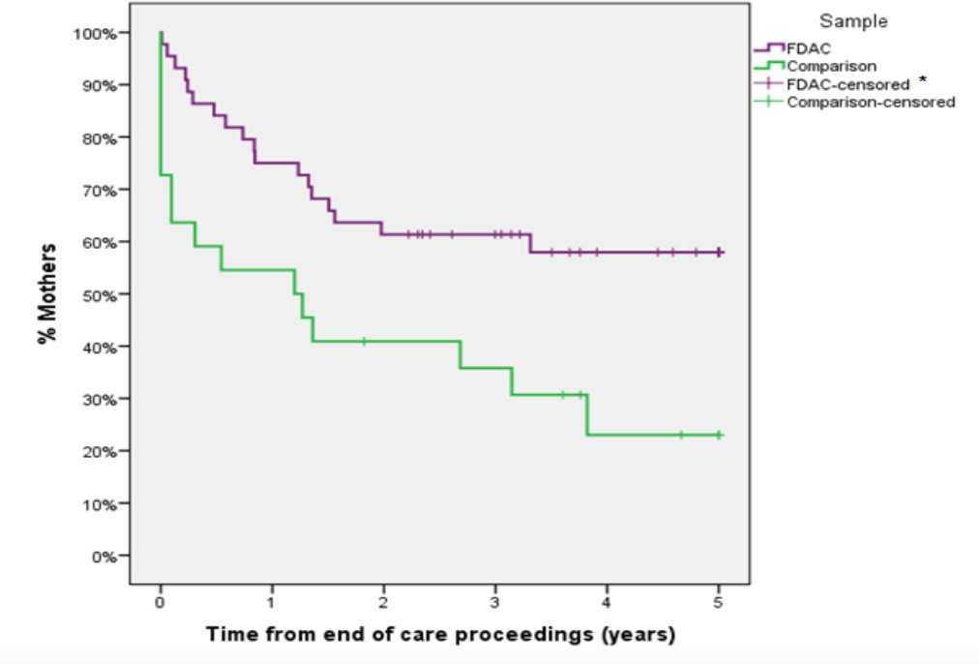

The level and quality of post-proceedings support provided by local authority children’s services under a Supervision Order is very variable.

The ‘fidelity’ model (see above) doesn’t include post-proceedings support. Although post-proceedings support was one of the recommendations of the 2014 evaluation ⁵ and some FDACs have experimented with post-proceedings support.
- The Early FDAC model included up to 2 years of intervention and where cases went into proceedings families were offered post-proceedings support with apparently good outcomes.
- In Gloucestershire FDAC workers are also the local authority’s children’s social workers and they work post-proceedings under a Supervision Order. Furthermore the FDAC judge invites families to come back and see her. Interestingly, to date no Gloucestershire placement has broken down post-proceedings, although numbers are very small.

Because of the focus on long-term outcomes the LCF FDACs were going to offer up to 2 years of post-proceedings support.

Aims of post-proceedings support

- To improve post-proceedings outcomes for children and families.

- To gain a better understanding of the problems that children and families experience post-proceedings.

Post-proceeding support

The Families

The plan had been for post-proceedings support to be available to all LCF FDAC families and for a description of this aspect of the service to be included in the leaflet that parent received with the Letter of Issue. While families can opt out of FDAC at any stage, the expectation was that they continued to work with FDAC post-proceedings.

We were likely to be left with two groups:
- Group 1 families: ‘Graduates’ who have made enough progress with their problems for it to be ‘safe enough’ to end the proceedings with the children remaining in their care (see Figure 3).
- Group 2 parents: Parents who made some progress with their problems, but not enough to have their children returned by the end of proceedings (see Figure 4)

Figure 3. Group 1 families: post proceedings support for graduates
S
a
f
e

e
n
o
u
g
h
H
a
r
m
f
u
l
B
o
r
d
e
r
l
i
n
e
S
t
a
r
t

o
f

C
o
u
r
t

P
r
o
c
e
e
d
i
n
g
s
C
o
n
c
l
u
s
i
o
n

o
f

P
r
o
c
e
e
d
i
n
g
s
2

Y
e
a
r
s

P
o
s
t
-
p
r
o
c
e
e
d
i
n
g
s
S
t
a
b
i
l
i
s
e

m
a
i
n
t
a
i
n

a
n
d

b
u
i
l
d

o
n

p
r
o
g
r
e
s
s
P
r
e
v
e
n
t

r
i
s
k
s

r
i
s
i
n
g

a
g
a
i
n
R
i
s
k
T
i
m
e

We thought it was likely that some parents, especially from Group 2, would disengage for a few months post-proceedings and then want to reengage. If we predicted this might happen parents might feel less awkward about returning.

With Group 1 families the aim of the post-proceedings support was to help the parents to maintain and build on the progress they had made over the course of the proceedings so that it was ‘safe enough’ for their children to continue living at home.

With Group 2 parents the aim of the post-proceedings support was to build on any progress the parents had made over the course of proceedings, so that at some point beyond the end of proceedings it would be ‘safe enough’ for them to care for these or future children.

Figure 4. Group 2 parents: Post-proceedings support for parents progress with their problems but not enough to have their children returned

S
a
f
e

e
n
o
u
g
h
H
a
r
m
f
u
l
B
o
r
d
e
r
l
i
n
e
S
t
a
r
t

o
f

C
o
u
r
t

P
r
o
c
e
e
d
i
n
g
s
C
o
n
c
l
u
s
i
o
n

o
f

P
r
o
c
e
e
d
i
n
g
s
2

Y
e
a
r
s

P
o
s
t
-
p
r
o
c
e
e
d
i
n
g
s
T
i
m
e
P
r
e
v
e
n
t

r
i
s
k
s

r
i
s
i
n
g

a
g
a
i
n
S
t
a
b
i
l
i
s
e

m
a
i
n
t
a
i
n

a
n
d

b
u
i
l
d

o
n

p
r
o
g
r
e
s
s

‘Cycle of Change’

The FDAC model builds on Prochaska & DiClimente’s ⁶ concept of the ‘Cycle of Change’ (Figure 5).

The model predicts a dynamic process where parents may be consciously trying to remain in the ‘Maintenance’, but will have a tendency to enter ‘Lapse/Relapse’, which will require a further ‘Cycle of Change’ to get back to ‘Maintenance’.

It is fundamental to any support provided, that the team maintain a realistic picture of where parents are in the ‘Cycle of Change’.

Given what we know from the follow-up research ¹² the team would be particularly alert to:
- Signs of child neglect or abuse

Substance misuse ‘lapse/relapse’
- Increased risk of intimate partner abuse.

Figure 5. Prochaska & DiClimente’s Cycle of Change
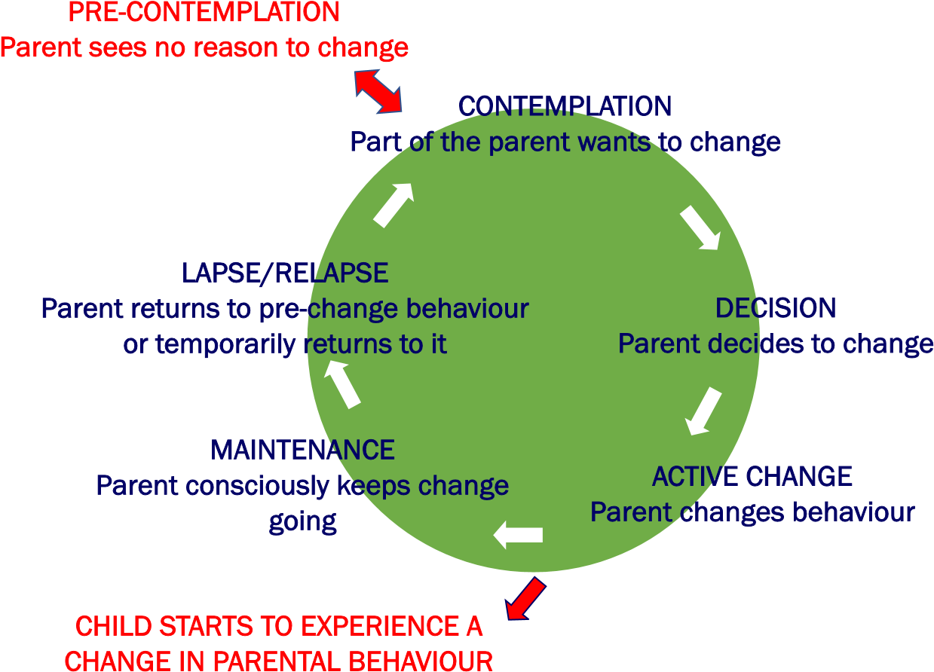

Maintaining the FDAC-frame

There are key elements of the in-proceedings model that we wanted to retain post-proceedings. Including; key work, therapy, Intervention Planning Meetings, judicial review and testing, however:
- There would be a flexible approach.
- In general support would be significantly less intense than it was during proceedings and taper off as we reached the end of the two year period.
- There would nevertheless be a capacity to increase the intensity of support in response to crises (particularly key work).

Key work
Key work is a central element to the way FDAC works. It allows the parents and team to be aware of where parents are in the ‘Cycle of Change’, and respond to crises.
- In some cases parents would continue with the same keyworker, but there may be value in a change of keyworker post-proceedings. This decision would be made by the team manager after listening to the parent and key worker’s views.
- The frequency of key work would be considerably less than the 1-2 times a week offered in-proceedings, in most cases it would be 1-2 a month.

Treatment
As with in-proceedings FDAC, when it comes to treatment the main role of the FDAC team would be to broker and coordinate the treatment provided by other agencies. But, the usual menu of in-house treatments would also be on offer post-proceedings.
- As with in-proceedings treatment the aim would be to plug the gaps rather than to duplicate treatments available from other agencies, and there may be regional differences in what each team offered.
- Group treatments have the advantage of offering peer support and can be a better use of resources.
- While working on ‘controlling risky and damaging behaviours’ would continue to be an important objective for parents with and without children in their care, it is likely that for Group 1 families (Graduates) the treatments would put more emphasis on ‘addressing traumatic drivers’, ‘strengthening parent child relationships’ and ‘creating a child centred lifestyle’ (see Figure 5).
- Group 2 parents wouldn’t have children in their care and ‘controlling risky and damaging behaviours’ and ‘addressing traumatic drivers’ would be their primary objectives.
- We would also improvise and innovate in responding to new problems that arise in the post-proceedings period, such as providing an open group for parents struggling with emotional and behavioural problems which can emerge especially in older children after post-proceedings rehabilitation.
- Family planning was to be an essential element of any plan.

Figure 5: Four elements of treatment in FDAC

C
o
n
t
r
o
l
l
i
n
g

r
i
s
k
y

a
n
d

d
a
m
a
g
i
n
g

b
e
h
a
v
i
o
u
r
A
d
d
r
e
s
s
i
n
g

t
r
a
u
m
a
t
i
c
d
r
i
v
e
r
s
C
r
e
a
t
i
n
g

a

c
h
i
l
d
-
c
e
n
t
r
e
d

l
i
f
e
s
t
y
l
e
S
t
r
e
n
g
t
h
e
n
i
n
g

p
a
r
e
n
t

c
h
i
l
d

r
e
l
a
t
i
o
n
s
h
i
p
s

Intervention Planning Meetings
The final in-proceedings Intervention Planning Meeting would draw up a plan for post-proceedings support, which would be agreed by the parties and the court at the Final Hearing.

Further Intervention Planning Meetings would be combined with the local authority social worker’s review of the ‘Child in Need Plan’ during the period of the Supervision Order and potentially beyond.
- Minutes would be produced and shared with the parties and judge.
- The frequency of IPMs would vary depending on the needs of the family but are likely to be every 3-6 months.

Judicial continuity
At the Final Hearing the judge would offer parents the opportunity to ‘come back and let me know how you are getting on’.
- At these post-proceedings judicial reviews the judge wouldn’t have decision making power and would effectively be seeing the parent as an ‘interested professional’.
- The judge may choose to see the parent in the court room (although court would not be in session), alternatively the meeting could take place in the judge’s chambers.
- In most other respects the judicial review would resemble a Non-Lawyer Hearing, with a Review Report, judge’s briefing and the children’s social worker in attendance.
- The frequency of the judicial-reviews would vary from case to case but would follow on from an IPM.

Testing
It would be useful to be able to test parents. The frequency of testing would vary a great deal from case to case.

Demand and capacity

The evaluation ⁴ predicts that;
- 35-40% of cases would be eligible for Group 1: (Graduates), and another
- 10-15% of cases would be eligible for Group 2: (Parents who make some progress)

If, to be on the safe side, we assume that all of the predicted parents opt into the post-proceedings support but on average they only remain engaged for a year (again a guess), it would follow that an FDAC team accepting 32 cases a year would have no more than 16 open post-proceedings cases and that wouldn’t occur until year 3-5 of the project.

To provide the post-proceedings support described one additional fulltime social worker would be required for therapeutic teams handling 32 new cases a year. Where additional skills are necessary they would be acquired and maintained by the whole team, allowing for flexibility and continuity if staff leave.

References

- Wade, J, et al (2011) Caring for Abused and Neglected Children: Making the Right Decisions for Reunification or Long-term Care. London: Jessica Kingsley Publishers.
- Farmer, E et al. (2011) Achieving Successful Returns from Care: What makes reunification work? London: BAAF.
- McFarlane (2017) Holding the risk: The Balance between Child protection and the Right to Family Life. The inaugural Bridget Lindley Annual Memorial Lecture.
- Harwin J, Alrouh B, Broadhurst K, McQuarrie T, Golding L, and Ryan M. (2018) Child and Parent Outcomes in the London Family Drug and Alcohol Court Five Years On:
Building on International Evidence. International Journal of Law, Policy and The Family, 2018, 0, 1–30 https://academic.oup.com/lawfam/advancearticle/doi/10.1093/lawfam/eby006/4962132
- Harwin et al 2014 http://wp.lancs.ac.uk/cfj-fdac/publications/
- Prochaska and DiClimente, 1986 ‘Model of Change’ adapted from http://www.nhsetrent.gov.uk/ph/drugsmisuse

